Lab 04:
Question#01:
CODE:
#include <iostream>
#include <string.h>
using namespace std;

class Employee
{
char *EmployeeName;
const int EmployeeId;

public:
Employee(int id, const char *name = "N/A") : EmployeeId(id)
{
EmployeeName = new char[strlen(name) + 1]();
strcpy(EmployeeName, name);
}
char *getName() { return EmployeeName; }
void changeName(const char *name)
{
delete[] EmployeeName;
EmployeeName = new char[strlen(name) + 1]();
strcpy(EmployeeName, name);
}
int getID() const { return EmployeeId; }
~Employee() { delete[] EmployeeName; }
};

int main()
{
Employee Employee1(1001, "Jhon"), Employee2(1002, "Jhonathan"), Employee3(1003, "Jhonny");
cout << "IDs\tNames" << endl;
cout << Employee1.getID() << "\t" << Employee1.getName() << endl;
cout << Employee2.getID() << "\t" << Employee2.getName() << endl;
cout << Employee3.getID() << "\t" << Employee3.getName() << endl;

Employee2.changeName("Jhonny");

cout << "\033[1;33m====After changing Employee2 name====\033[0m" << endl;
cout << "IDs\tNames" << endl;
cout << Employee1.getID() << "\t" << Employee1.getName() << endl;
cout << Employee2.getID() << "\t" << Employee2.getName() << endl;
cout << Employee3.getID() << "\t" << Employee3.getName() << endl;
return 0;
}

OUTPUT:
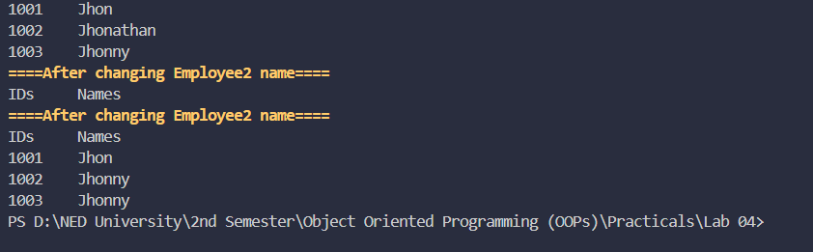

Question#02:
CODE:
#include <iostream>
using namespace std;

class DynamicArray {
private:
int* arr;
int size;

public:

DynamicArray(int size) : size(size) {
arr = new int[size];
for (int i = 0; i < size; i++) {
arr[i] = 0;
}
}

~DynamicArray() {
delete[] arr;
}

void push(int value) {
if (size > 0) {
arr[size - 1] = value;
}
}

int getSize() {
return size;
}
void printArray() {
for (int i = 0; i < size; i++) {
cout << arr[i] << " ";
}
cout << endl;

}

};

int main(){
DynamicArray myArray(5);
myArray.push(10);

cout << "Size of the array: " << myArray.getSize() << endl;
cout << "Array elements: ";
myArray.printArray();

return 0;
}

OUTPUT:
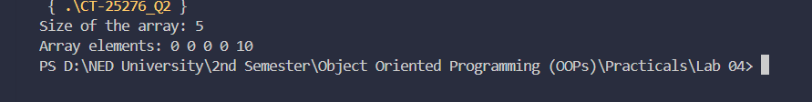

Question#03
CODE:
#include <iostream>
using namespace std;

class Account {
private:
int account_no;
double account_bal;
int security_code;
static int object_count;

public:

Account() {
account_no = 0;
account_bal = 0.0;
security_code = 0;
object_count++;
}

void initialize(int account_no, double account_bal, int security_code) {
this->account_no = account_no;
this->account_bal = account_bal;
this->security_code = security_code;
}

void print() {
cout << "Account Number: " << account_no << endl;
cout << "Account Balance: " << account_bal << endl;
cout << "Security Code: " << security_code << endl;
}

static int getObjectCount() {
return object_count;
}
};

int Account::object_count = 0;

int main(){
Account acc1;
acc1.initialize(12345, 1000.0, 6789);
cout << "Account " << Account::getObjectCount() << ":" << endl;
acc1.print();
cout << endl;

Account acc2;
acc2.initialize(67890, 2000.0, 1234);
cout << "Account " << Account::getObjectCount() << ":" << endl;
acc2.print();
cout << endl;

cout << "Total number of Account objects: " << Account::getObjectCount() << endl;

return 0;
}

OUTPUT:
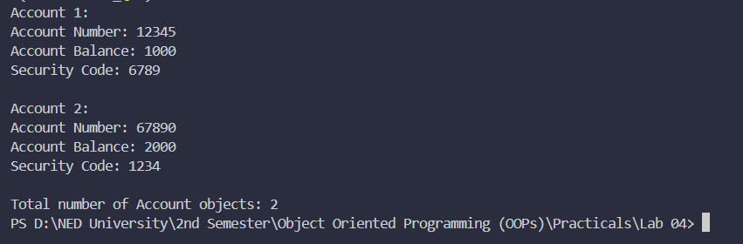

Question#04:
CODE:
#include <iostream>
using namespace std;

class Student {
private:
const int rollNumber;
string name;
int age;

public:
Student(int r, string n, int a) : rollNumber(r) {
name = n;
age = a;
}

void display() const {
cout << "Roll Number: " << rollNumber << endl;
cout << "Name: " << name << endl;
cout << "Age: " << age << endl;
}

void changeAge(int newAge) {
age = newAge;
}

};

int main() {
Student s1(101, "Ali", 20);

s1.display();

s1.changeAge(21);
cout << "\nAfter updating age:\n";
s1.display();

return 0;
}

OUTPUT:
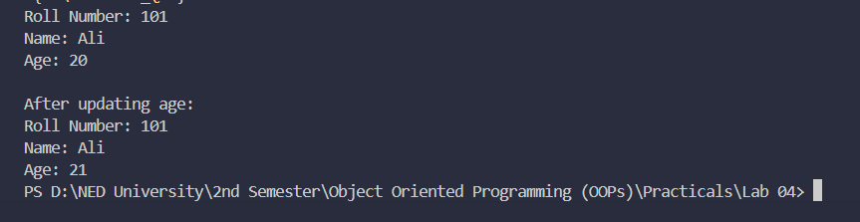

Question#05:
CODE:
#include <iostream>
using namespace std;

class HotelMercato {
private:
const double rent_per_day;
string customer_name;
int days_stayed;

public:

HotelMercato(string customer_name, int days_stayed) : rent_per_day(1000.85), customer_name(customer_name), days_stayed(days_stayed) {}

double getPerDayRent() const {
return rent_per_day;
}

double calculateRent() {
if (days_stayed > 7) {
return (days_stayed - 1) * getPerDayRent();
} else {
return days_stayed * getPerDayRent();
}
}

void display() {
cout << "Customer name: " << customer_name << endl;
cout << "Days stayed: " << days_stayed << endl;
cout << "Rent: " << calculateRent() << endl;
}
};

int main(){
HotelMercato customer1("Faarid Amir", 20);
customer1.display();

return 0;
}

OUTPUT:
